**Application of Information Technology in Accounting**

**Dissertation Report**

**Submitted in fulfilment of the requirement of BITS G561T Dissertation**

**By**

**Arshiya Begum**

**2013H149026U**

Under Supervision of

**Aqila Rafiuddin**



**BITS Pilani, Dubai Campus**

**Dubai International Academic City, Dubai**

**UAE**

**September 2015 – December 2015**

# **Declaration**

I, Arshiya Begum, declare that this mid semester dissertation report is my original work. It has not been submitted to any other university or higher institution for any award and where it is indebted to work of others, due acknowledgement has been made.

**Student**

Signed………………………………………………………….. Date………………………………………………………………………

**Supervisor**

This project paper has been presented for examination with my approval as University Supervisor

Signed………………………………………………………….. Date………………………………………………………………………

# **Acknowledgement**

I would like to take this opportunity to thank Almighty God for His guidance, care and providence which enabled me to undertake this project.

My sincere thanks also go to the Tableau Software organization for providing access to professional business intelligence licensed software, Python Software for providing licensed software with compilation IDE that came in handy in doing this research. I am also glad to note that BITS Pilani Dubai Campus for granting me an admission into the higher degree program to pursue MBA and to undertake this worthy project.

I am also indebted to my supervisor Mrs. Aqila Rafiuddin for the role she played in guiding me during the entire research period. She was a source of encouragement and their thoughts contributed greatly to my success.

Lastly but not least I acknowledge my family and friends for both financial and moral support they provided while I was working on this project.

# **ABSTRACT**

Many organizations have evolved from account booking keeping era to computerised accounts databases management systems. The effectiveness and efficiency of accounting software’s depends on performance and usefulness of the accounting software’s with reduced dependency of manual interventions in financial record maintenance and statement generations. This can be achieved by automation of the financial statement generation, strong data validation rules etc.

To achieve competitive advantage organization acquiring accounting software’s for data validation and generation for financial statements is not sufficient, apart from financial statements generation the capability of analysing the financial statement for effective, accurate and timely decision making process is required. The accounting software should also include the business intelligence handle for analysing the financial statement, apart from data validation and financial statement generation serves as an extended accounting software’s commonly referred as Accounting Information System (AIS). The concern in many organizations is to identify the extent of inter-dependency between the accounting processes and other businesses processes in order to achieve effectiveness in the decision making process.

The main objective of this project is to identify and establish the effect of different information technology software applications in the accounting sector of any organization. The goal of this project is to identify the relationship between the accounting information system (AIS) and an organizations many other business process for organization’s profitability. AIS is the briefly defined as the set of different hardware and/or software systems inter connected to collect, store, process, retrieve the crude financial to generate processed and clean financial information to be used by the management for decision making purpose. Therefore, impact of AIS on elements of organizational performance such as: performance management and financial performance is examined. The objectives of this study includes the creation of the Accounting Information System.

Accounting Information System in this project in a nutshell would be a three step process using three different software’s with varying complexing at each step: Data Validation forms the first step of the Accounting Information System. In this step a standard Microsoft excel software is used with basic data validation rules and summation logic to be incorporated to form the balance sheet, it is up to the personals due diligence to enter the entries in balanced format. The Second step of the Accounting Information System would be a software to read the data from the balance sheet generated from the first step and form different financial statements such as Income Statement etc. The final step of the Accounting Information System be the Business intelligence system which wold take the journal entry excel sheet of an organization and analyse the data to generate dashboards, weekly/monthly/yearly reports, project graphs etc. which would be effective for decision making process

.Conclusively, the study would majorly focus on different information technology software’s for varied difficulty level for collecting, storing, retrieving and maintaining accounting information invariably referred as accounting information systems with extended capability of analysing the accounting information for advanced, accurate, efficient knowledge for enhancing the decision making process of an organization to achieve competitive advantage over the other equally competent organizations in the market.

# 

# **ACRONYMS**

AIS – Accounting Information System

FIS - Financial Information System

GAAP - Generally Accepted Accounting Principles

IASB - International Accounting Standards Board

IFRS - International Financial Reporting Standards

IARS - International Accounting Reporting Standards

IS - Information Systems

IT – Information Technology

MAIS - Management Accounting Information Systems

MNC – Multi-national companies

PMS - Performance management Systems

ROI - Return on Investment

ROE - Return on Equity

SDLC – Software development Life Cycle

SME – Small and Medium sized Enterprises

**Table of Contents**

**Declaration** i

**Acknowledgement** ii

**ABSTRACT** iii

**ACRONYMS** v

**List of Figures** viii

**1.** **Introduction** 1

1.1 Terminology 1

1.2 Background 2

1.3 Research Problem 4

1.4 Objective of the project 6

1.5 Importance of the study 6

**2.** **Literature Review** 7

2.1 Introduction 7

2.2 Theoretical Literature 8

2.2.1 Contingency Theory 8

2.2.2 Agency Theory 9

2.2.3 Behavioural Theory 10

2.3 Empirical Literature 11

2.3.1 AIS and Financial Performance 11

2.3.2 AIS and Organizational Effectiveness 12

2.3.3 AIS and Performance Management 14

2.3.4 AIS and Data Quality 16

2.3.5 AIS and Internal Support Functions 17

2.4 Criteria of measuring the performance of AIS 19

**3.** **Research Methodology** 21

3.1 Introduction 21

3.2 Classification of research 21

3.3 Proposed System 22

3.4 Assumptions 25

3.5 Limitations 25

**4.** **System Design Flow Chart** 26

**5.** **AIS Software Design** 28

5.1 Balance Sheet Template 28

5.2 Generation of Financial Statements Automation through PYTHON 29

5.2.1 Output Generated out of the GenerateStatements.py 33

5.3 Analysis and generation of repots ad dashboards using TBALEAU 34

5.4 Scope for Future Research 35

**6.** **Conclusion** 37

**References** 38

# **List of Figures**

Figure 3‑1 List of Sub Sections in Research Methodology 13

Figure 3‑2 Proposed AIS system design model 16

Figure 4‑1 Flow Chart of AIS 17

Figure 4‑2 Flow chart of the automation of financial statements sub system 18

Figure 5‑1 Software flow between activities 18

Figure 5‑2 Balance Sheet Template Screen Shot 19

Figure 5‑3 Drop-Down Population Data 19

Figure 5‑4 Income Statement Screen-Shot 23

Figure 5‑5 Cash-Flow Statement Screen-Shot 24

Figure 5‑6 Retained Earnings Statement Screen-Shot 24

Figure 5‑7 Dashboard generated through tableau 9.0 25

# **Introduction**

## Terminology

***Information technology***, also known as IT is collectively known as use of hardware, software and networking devices to collect, store, process, retrieve and transfer data across various systems. Information technology plays an integral part not only in advanced highly equipped systems but also in basic minimal components systems. Now a days almost every organization is investing in information technology to achieve competitive advantage over other competitive organizations. Companies implementing different business strategies use information technology in different contexts for example companies implementing differentiation strategy use information technology to create products with very high level of innovation and focus on convenience as the differentiating factor which can be achieved by automating the products using information technology, whereas companies incorporating low cost strategy use information technology for increasing productivity of the work force thereby reducing operating cost which implies decrease in the cost of the product. However information technology to provide competitive advantage to any organization involves heavy star- up cost.

***Accounting*** is a procedure followed in every organization which involves collecting financial information of the organization, analysing the collected information and preparing financial statements. Different financial statements are balance sheet, cash flow statement, income statement and retained earnings statement etc. These financial statements are maintained across all dimensions and sizes existing organizations. Accounting information is used for analysing the financial and strategic position of an organization in the competitive market. All these financial statements are prepared at different intervals of time i.e.., monthly, quarterly, half yearly or yearly depending upon organizations financial policy but as per GAAP issued format. Financial statements are not only used for identifying organizations position but also by company’s stakeholders for making investing decisions.

***Accounting Information Systems*** is referred as collection of different computer devices that are organised together to perform multiple series of operations including collecting, storing, analysing, retrieving, processing, posting and preparing financial information to equip decision makers with the required information for making effective and efficient decisions and enhance decision making process. Accounting information system are gaining popularity and importance in the new error of the business management by helping decision makers with the right and exact data with minimum effort. Unlike accounting process, accounting information system uses advance different technologies and makes the accounting process automated with minimal human intervention whereas accounting require complete manual intervention. Accounting process is automated using information technology but based on accounting rules and principles thereby incorporating both the departments under a single process.

Accounting Information System forms an integral part in the value chain in the financial cycle of any organization by forming synergy between information technology and the accounting systems, composing two systems into a single system and performing operations of both the systems into a single system. Value added by the accounting information system adds value to the entire organization by enhancing the work force productivity, efficiency and effectivity of the organization decision making process, budgeting process, stakeholder’s contribution and many more. Accounting information system generally comprises of many stages out of which few stages require manual intervention to provide input to the automated system for generating reliable error free financial statements in human understandable format time effectively.

The main aim of this project would to minimize manual intervention in the accounting information system. The research project would also focusing on validating the input data efficiently. Also analyse the financial information to create reports and graphs to enhance decision making process.

## Background

As the businesses are evolving due to the dynamic changes and changes in the requirements in the competitive market, managers in the today’s world are switching to information technologically managed systems in every aspect of the business from production control to financial management systems. The key ingredient of any business now a days is information and maintenance of information is gaining importance. Maintaining information was followed from very being in records, registers manually but with the advancement in the technologies maintenance of information is possible through automation with minimum effort thereby comparatively less work force efficiently and effectively. One of the advantage of implementing information technology in an organization is it can be moulded in any form to complement any strategy practised in the organization. There are many benefits of using information technology in the business such as increases productivity, reduces time, provides reliable bug free data, low maintenance of the system etc. Hence combining information technology with the information mainly in the financial department introduces to a new concept called accounting information system.

Accounting Information System (AIS) is a system in combination with Information and technology (IT) systems which are designed to assist organizations management in the financial department. Information systems (IS) forms an important role in the accounting information system. Advancement in the information technology sector more precisely in the information systems occurred in the last few decades but the twentieth century had the wide range of accounting information systems features (Mitchell, 2000). Accounting information systems usage and benefits can be viewed from different point of views. One of the viewpoint being accounting information systems contribute to the strategic success of an organization. Companies implementing different strategies depending on the companies’ stages in the companies’ life span uses accounting information system expecting benefits with respect to different viewpoints, for example companies implementing first move strategy use accounting information system for using accounting resources for innovation where as companies implementing large customer base benefit use accounting information system to reduce work force and reduce the cost there by reducing the product cost. Accounting information system adds value to the organization by providing vital and processed information to the managerial understandable information so as to enhance the decision making process to make efficient an effective decisions by all the stakeholders of an organization. One of the author interpreted accounting information as business language that provides scripts for financial information (Wilkinson, 2000).

Several studies argue that accounting information systems contribute to the strategic success of an organization. The role of accounting information system in the managerial success of a manager in any organization is achieved by prioritizing the strategies implemented in the organization. The effect of the performance fluctuations by implementing different strategies and prioritizing the strategies by incorporating accounting information systems into the organization has portrayed higher reliable performance. Different types of accounting information systems provide performance benefits when used in appropriate combination of strategy. Organization focusing flexibility accounting information systems with advanced technology with higher scope provides higher performance. Organizations focusing on innovation and incentive strategy, accounting information system with moderate technology would provide higher performance.

Accounting Information System in short is used to record financial transactions of an organization, process the financial data to generate reliable financial statements analyse the financial statements to project the financial information to make efficient decisions across the different level of stakeholders thereby increase the profitability and performance of the organization.

## Research Problem

In today’s world using information technology, information systems or any technology has become necessity unlike previous decades where technology was interpreted as luxury. However with the advancement in technology and availability of wide range of technical products and resources across the globe implementing and incorporating information technology is possible for almost all possible dimensions of organizations ranging from SME’s to MNC’s. The challenge now most of the leading organizations are facing is to how to use information technology to gain competitive advantage over the rivals.

The growing information technology sector and the importance of financial sector form the key driving force for the development of accounting information system. These factors are the driving forces for the advancement of the information technology in the financial sector of all the organisations. The firms focus on achieving competitive advantage by developing or investing into efficient and personalized accounting information systems to gain synergy between market and companies operations globally and economically in the financial markets. The emerging information technology sector is majorly developed by typical traditional accounting processes due to inefficient maintenance and difficultly in retrieval of information from the old traditional systems which have a negative impact on the companies maintenance cost.

Accounting Information Systems is a growing research area for many finance specialities and researchers. Accounting information systems and management accounting system go hand in hand because both the systems rely on financial information extracted out of accounting information system based on the information extracted decision- making process is carried out. The fit between an organizations requirements and accounting information system is achieved by tracking the input data fed to the accounting information system i.e.., the financial transactions incurred and recorded in the organization and output generated from the accounting information system is further used in the decision making process which thereby leads to the financial and economic development of the organization.

The interdependency between the accounting information system and an organizations performance and effectiveness has been researched topic for many research papers. Many researchers has found that there is a strong dependency between accounting information system performance and organizations effectiveness and profitability. Depending upon the complexity level of the organization requirement and the advancement or level of technology used to develop the accounting information system the outcome and the benefits from the usage of accounting information system varies.

This current study examines in detail three possible explanations for the gap. First, is the deficiency in validating of data used in accounting information systems to practice and secondly, the insufficient use of the information technology in accounting and finally analysing the accounting information for business decision making process. It will examine the use and logic of transformation of accounting in the accounting information system. This study departs somewhat from the above practice of focusing on the ways in which specific information technologies affect the operation of organizations but specifically focus on the impact of Accounting Information Systems on the effectiveness of the decision making process.

## Objective of the project

The objective of this project is to determine the application of different information technology applications in effective maintenance of accounting information and using accounting knowledge for decision making process.

## Importance of the study

The study is of importance of information technology in accounting sector in terms of determining the benefits accruing due to the integration of accounting information systems in their operations.

The study would provide a theoretical basis about accounting information system successful adoption dimension to firms. It would provide practical guidance for accounting information systems implementation in small and medium business and it would also provide empirical and practical contributions for organization in effectively applying accounting information system in their operations. Accounting information systems provide information about the financial resources, obligations, and activities of an enterprise that is intended for use primarily by external decision makers – investors and creditors. This study provides useful information in making investment and credit decisions

# **Literature Review**

## Introduction

Information technology era has evolved the way in which traditional accounting process can be tackled and automated, accounting information system is intended to reciprocate traditional non-conventional manual accounting process to automated systematic computer programs and systems. Hence, historical accounting process were incapable to project flexibility with the changing environment and changing needs and requirement of the accounting and the book keeping processes practised. To adapt to changing requirements and the environments, and to support critical business systems with dynamic requirements. Current era of accounting information systems (AIS) can provide not only provide traditional accounting information systems functionality but also provide advanced analysed financial information for effective decision making process in few clicks within few seconds of turnaround time which would be helpful in the long term strategic decisions of any organization (Mitchell, 2000).

Few of the path breaking benefits of having efficient accounting information systems (AIS) in an organization would be, Speed, Accuracy, Flexibility, Book Keeping & Storage, Information Accessibility, Security & Authorization, Up to date information, Easy maintenance and management of information, Improved Quality, Cost reduction in long run, etc., thereby providing competitive as well as non-substituted advantage (Elena Urquía Grande, 2010). One of the major advantage of effective, intense and long term use of accounting information system is the easy access and privileged user’s authority, retrieval across the globe and long term data i.e.., data from the decade also can be stored and retrieved a few clicks away unlike the manual process.

The effort to internationalize accounting standards began in 1973 with the formation of the International Accounting Standards Committee (IARS). However, in 1988, it became apparent that a full-time rule-making body with global representation was necessary; so the International Accounting Standards Board (IASB), with members representing 9 major countries, was established. The IASB was charged with the responsibility for creating a set of International Financial Reporting Standards (IFRS). A global accounting structure would enable investors and practitioners around the world to read and understand financial reports produced anywhere in the world.

This projects literature review focuses on explaining research work from other authors and researchers from the finance field. The portion of the paper revolves around different theories proposed and used in different research papers, conclusions, proposals, opinions, objectives, methodologies etc.

## Theoretical Literature

### Contingency Theory

This theory proposes that accounting information system (AIS) design should be flexible enough to adapt to changing environment, network and clients evolving requirements which are as time passes are becoming dynamic in nature. The processed information obtained from the accounting information system implementing flexible framework not only will be helpful in the generate and store financial information in dynamic environment but also in other stakeholders decision making process related to investment, operations etc.

Information systems programed and designed based on the fundamentals of the contingency theory tend to be more reliable because of the special importance given to disaster management i.e.., due to its dynamic nature adaptive feature there may be unforeseen failures and break downs occurring, disaster management provided a backup plan to be taken up in-case of the unprepared and unplanned failures.

Contingency theory projects that any organizations’ profitability and efficiency increases as an outcome of the communication between businesses processes, organizational hierarchy and structure. The relationship between the organizations structure and the context of accounting information system design leads to performance improvement and organization development (Mohammed Al-Omiri a, 2007). Many researchers’ agree with this contingency approach, that involves testing the communication between the contingency expected features and the design of the accounting information system and the measure of the organizations profitability (Boulianne, 2007). This paper findings include the relationship between the contingency factors and the accounting information system and the impact of both on the organizations efficiency and effectiveness. However there are many assumptions to be imposed before implementing this theory, the main basic assumption of this theory is that all the factors and features are inter-related and interdependent on each other and appropriate resources must be allocated so that the factors communication to be possible and feasible.

One of the author concluded that each factor that controls the impact of organizational requirements and features on organizational profitability is used as the contingency variables. The contingency theory also presumes that the impact of one feature on other feature depends on all the contingency system attributes.

Due to extensive research work carried in the last few decade, contingency theory has not been explored much in terms of the variability and reliability that impacts the accounting information systems (AIS). However the impact of inter communication between the contingency features and AIS and the resultant organization profitability is yet to be answerable. This project mainly relies on answering the above questions by implementing practical system of accounting information features of contingencies examined on some sample set of financial data.

### Agency Theory

In this theory we will study mode about the relationship between an organizations management and the stakeholders. In the previous section contingency theory was not much explored in the last few decades but agency theory was much talked and researched area. Since this theory focuses on the relationship of stakeholders and the other people of the organizations the effect and impact of the relationship can have major and high effect on the organization development, hence prime attribute of agency theory which made it more researched concept for many management and financial researchers is that it explicitly resolves and provides the solution for conflicts, compensation settlements and negotiations and many other resolutions for controlling inter organizational problems. This theory should not be neglected because in a way this theory has motivational quotient for any accounting and managerial personals and any other company professionals.

There is a myth that most of the people presume that the principals i.e.., the management of an organization are not impacted by the risk i.e.., neutral in term of risk taking feature whereas the agents i.e.., the stakeholders are risk proven all the risk are to be taken by the stakeholders. It all depends on the majority of the principals in any organization, i.e.., Type-A principals are the ones who are self-motivated, expertise, positively approachable, helps and resolves issues and proactive in nature but Type-B principals are the ones who are reluctant to work, should be motivated by others, hence companies with majority of type-b principals have negative impact of the overall company progress but majority of type-a principals generally is assumed that will result in high performance but may also may lead to conflicts which if taken in a competitive and professional development perspective may lead to organization progress but if taken against each other may lead to download of the organization. Hence many organizations have contract policy with respect to compensation terms and conditions to bring the conflicting factors into balance. The equilibrium rule defines the allotment of output fit between the principals and the stakeholders is referred to a contract, whether spoken or unspoken. So, this theory gives a tool for direct contact between the economic factors related to compensation contracts depending on effort levels.

But there are few loop holes in this theory which requires further inspection and analysis. Few of the assumptions undertaken in this theory are, performance factors should be considered while appraising and negotiating the compensation contract. There must be pre-established frequency of the variable profit share and interest to be paid and many more. There can be debate on there is no much possibility of improvement between the investors and the stakeholders if this theory is implement, but this can be counter parted by having the re negotiation and reconciliation.

Agency theory included in the AIS can be used to answer few of the questions related to the conflicts arising situations as well as improve organization profitability. How can compensation problems be solved by providing company standards pay thus still achieving high employee satisfaction? – this can be achieved by automating most of the process so that reducing work force and increasing organization performance thereby less employee’s high pay and high performance can be achieved. Therefore, agency theory can be helpful in resolving inter-organizational conflicts related to compensation, motivation, work satisfaction etc.

### Behavioural Theory

In the early year behaviour theory was described as the relationship between system requirements (flexibility, automation, run time instant results) and features and many other performance characteristics such as profitability, budget, cash flows, liquidity etc. As this theory evolved over the past few decade, this theory shaped into more huge and complex model.

Few of the assumptions in this theory are, limited number of organization features are taken under consideration corresponding to the system attributes. Second assumption is best fit between organization features and system attribute is assumed to have positive effect on the organization. Behavioural theory starts with the thorough understanding of the organization variables and the system features, establishing a match between the features and variables. Finally identifying the best fit variable and feature pair which produces maximum positive outcome and high performance to the organization.

## Empirical Literature

### AIS and Financial Performance

According to authors (Gerdin J., 2004) accounting information system is composed of mainly few information variables, i.e.., aggregation, scope and lifetime of variable, and integration. One of the major advantage of the accounting information system is that the data fed to the AIS can be dated as old as a decade as latest as today, internal to the organization or can be external coming from outside the organization. The nature of the data can be cash related or non-cash related. Scope and lifetime of an attribute means the validity of the attribute and time period for which the attributes are available i.e.., applicable in the AIS. Aggression attribute is best defined as synergy between the attributes and the systems performance thereby reflecting the organizations total performance. And the decision making process. Integration is communication and coordination between the information and various organizational operations and function dependent on the information provided by the AIS. Finally strategy, the impact of strategy on the information availability and the quality of data extracted and in turn effecting the overall contribution to the organization effectiveness.

Exceptional performance of individual SBU’s of an organization depends on the designing and implementation of type of AIS and the strategies enforcing the alignment of performance factors and attribute (Boulianne, 2007). Hence many researchers started contributing studies on impact type and design of AIS and undertaken strategy on overall efficiency and profitability of the organization. The key lies in identifying type best suited for the current strategy implemented in the organization (Gerdin J., 2004). According to (Elena Urquía Grande, 2010) there is a noted and high degree of association between design, strategy and performance of the AIS and the organization. The present researched literature provides an insight on the inter-dependency between the AIS and the financial profitability and the performance of the organization.

AIS and financial profitability is achieved through automation of financial system decreases turnaround time and the resources utilised per work unit which in turn implies more productivity with less work force. Moreover the processed information availability across the globe at any moment with just a single click which makes the decision making efficient enough not only to the management but to the all stakeholders involved and associated with the organization directly or indirectly (U. Hoitash, 2009).

Managers requires financial input information to be fed into the AIS to draw the past performance and to forecast future expected performance and results. Here the organization profitability and results are measured in terms Return on Investment (ROI), return on equity (ROE) and the amount of liquid cash available with respect to the financial investment ratio values (Alsharayri, 2011). Return on equity is the percentage of debt capital in the total capital tree as the debt ratio increase the organization gains advantage in term of the savings and profitability (Oguntimehin, 2001).

Thus the trio AIS, financial profitability and the organizational performance and inter linked to each other, positive effect of one will have positive impact on other two and vice versa. Hence, to improve organizations overall performance financial foundation must be effective, the foundation can be laid strong only if the AIS is built effectively which in turn depends on the type of the AIS used and the information fed to the AIS.

### AIS and Organizational Effectiveness

AIS is expected to be cost effective and work force efficient enough to obtain reliable, bug free and timely information. The area of interest is to generate financial timely information through the optimal usage of resources. An efficient AIS generates processed financial information by any resource authorised to execute the different stages of the accounting information extraction cycle. The validity of the data can be generated at different stages of the AIS process can be verified manually and conclude that the AIS systems provides reliable, hazel free and bug free financial sensitive information. The information obtained from AIS is accurate before each stage of the AIS is developed on different platforms. The only hick up of the AIS process is that the financial or the business transactions much be recorded manually and carefully fed to the AIS system, unless the input data is correct output generated will not be useful. Performance oriented AIS is quality approved if it preserves the authorization and provides access privileges.

According to the author (Patel, 2015) profits and profitability does not have a standard definition, different people perceive profit in different terms based on value of their interest, but in this paper profit is generally described as gaining returns comparatively more than the amount being invested in to a business periodically over a period of time. Another definition from an investors point of view profits would be progressing the business over a period of time. From a lay man’s perspective profit is revenue gained more than expenses incurred. From a financial professional point of view income earned after deducting cash outflows from cash inflows. From a business front profit is the major attribute in accessing a business. Profit in association with market growth rate and market share of the business is considered while determining an organizations rank in the market which is helpful for the investors and other stakeholders of any organization. Return on investment is looked upon as an important measure of business’s progress and organization development. Apart from this measure there are many financial ratios are also referenced which preparing forecasts of cash flows and budget.

Automating the accounting process improves organizations effectiveness and performance, this point can be proved by identifying the relationship between automated AIS and the organization effectiveness and efficiency. Many papers have concluded that the value chain of an AIS can be measured in the context of stock value of the equity share, raise in share price relate to organizations effectiveness as performance increase in the organizations efficiency and profitability. The current financial statements preparation tool and the financial information system a reporting process also plays major role in the organizations performance, since he reporting tool information is ultimately used in the future forecasts and future progress of the organization (Hunton, 2002).

Comparison between the performances achieved by incorporating automated AIS design model, strategy and the type of selected with the traditional accounting method with the same strategy implemented in the automated model the results achieved explains that efficiency and effectiveness of individual strategic business unit and collectively all SBU forming a complete business of an organization have high increase of the overall productivity of an organization as well as individual SBU success (Boulianne, 2007). Finally concluding AIS improves strategic strength of a business as well as overall organizations performance.

### AIS and Performance Management

In the past many of the researchers claimed and concluded that there is an inter-dependency between the performance management practices incorporated in an organization to the performance of the AIS. Accounting information or data is directly associated to the decision making process of any organization, hence the output of the AIS will have direct and major impact on the organization future developments and future proposals and prospectus. Since the inception of AIS over the last few decades the impact of AIS performance to the organizations overall growth claims a very critical position in any organization. Performance maintenance and appraisal process in an organization is a set of several activities and methods put together to analyse individual resources performance and thereby analysing the overall companies total performance over a period of time at regular intervals. The analysis includes identifying the positive contribution and negative effect of a resource, in turn formulating the strengths and weaknesses, then over the next appraisal period working on the weaknesses and converting the weaknesses to the strength and then re-analysing the strength and weaknesses over an over at different intervals until all the weakness are either converted to strength or at least the weaknesses are not weaknesses any more. This processes can be achieved by setting goals and working on these goals as target for a specific appraisal cycle.

Accounting information plays a vital role in the performance management system (PMS) of an organization, by providing statics and analytical reports of the resources from a financial point of view. Appropriate and effective information adds value to the organization. AIS and organization development go hand in hand for organization progress. A stakeholders related to an organization require qualitative and statistical information for investment related processes for future organization development and progress (Flores, 2001). Financial information is not only required in the investment related decisions but also in the supplier and distributer relationship development. Business managers use AIS information more regressively for decision making process. Generally this information is provided by the financial professionals such as accountants, CA etc., which is then analysed and reported by the business managers for making decisions by automating transaction recording is the only part handled by the accountants, but the later part of the accounting process such as processing and analysing the financial information to managers usage format will be handled by AIS making the accounting process for the users to be much simpler and easier.

The common practice for performance measurement and ranking of an organizations performance is carried out by setting goal at the beginning of the performance cycle and at the end of the performance cycle analysing the goals fulfilled there by the strengths and the goals not met there by the weaknesses. Based upon the strengths and weaknesses identified setting new goals for next cycle until all the weaknesses becomes strengths. This was in the resources performances management likewise managers need to identify strengths and weaknesses from the financial perspective and risk and other assets and liability management for future investments and growth related aspects and decisions of an organization. Hence records and book keeping and efficient information availability and performance and emphasis on financial aspect of an organization is given equal importance or rather even more importance than the PMS of resources in an organization.

PMS and AIS are growing importance in the start-ups as well as large customer based business because future of the business rely on the above two systems efficient and effective performance in short span of time for timely results and profitability. The aim in this type of systems is to focus on only weaknesses and challenges and to convert weaknesses to positives as efficiently and quickly (Tidd J., 2005). The businesses which follow differentiation strategy where creating a new market for themselves often find it much easier than any other type of business strategies practicing organization because of the upper hand of having a new and unexplored area of competition. Companies practising low cist strategy may have few difficulties because a customer base is already established and slashing he price may work out once because here is always a threat of competitors too implementing the same strategy and further reduction may not balance out the company’s expenses and cost incurred and profitability.

Hence, the inter dependency between AIS, PMS and organization profitability can be controlled by the PMS and/or AIS in conjunction with each out resulting a higher performance rather than implementing stand-alone systems. AIS conjunction with PMS implies organization growth and advancement in the business. Hence, either ones bad performance PMS or AIS would have direct negative impact on an organizations present as well as future growth in the long run which is very difficult to reverse.

### AIS and Data Quality

The data fed to any systems will have the direct impact on the output generated out of the system. If the input data though raw in nature but is not in the expected format then the result generated may not be as desired or expected out of the system. Many things come together generates a correct and reliable output such as AIS is made up of multiple stages or steps, each stage is again considered as an individual as a whole in itself, thereby for each stage input for that stage should be in the expected format and the output from one stage is fed to the next consecutive stage thereby output of the previous stage should be understandable by the next stage. This requirement revolves in a loop in the AIS system as a cycle. Though many authors stated and it is logically proved that, incomplete and garbage data causes more damage than not providing data.

Correct and expected format data when supplied to the AIS can ultimately provide successful output otherwise may lead to wrong and inaccurate data there by which leads to inappropriate decisions, wrong and out of context decisions (Bovee, 2004) and (H. Sajady, 2008). Input data accurateness can be validated and verified by different variables such as accuracy, completeness, substitutability, consistency and variability etc. If an input data file the above characteristics this type of input data may result in accurate and complete output which can be used an applicable across and length and breadth in the organization.

In the latest release of few papers on AIS concluded that the top management personals contribution and the data fed to AIS has very large impact on the financial performance of the organization. This is because, if the incomplete data is provided in the IAs would will output incorrect output which in turn provides managers with wrong reports and forecasts thereby leading the management to take inappropriate and incorrect decisions, hence resulting in often irreversible loss to the organization.

### AIS and Internal Support Functions

Internal support functions comprises of group of activities, processes, method, routines designed and followed by the organizations as formulated by the organizations guidelines. An organizations culture shapes up based upon the response and implementation of internal support functions by the stakeholder, staff and management of an organization.

AIS and internal support functions relationship is identified as crucial and important in an organizations day to day activities. A logical fit between managerial decisions and the accounts of an organization, to achieve the fit the link can be achieved by an efficient AIS incorporated in an organization. The output of the AIS is used in making decisions pertaining to investment, operations, resource management, appraisal, production control and budget proposal and forecast applicable for the next business cycle. The key for all this decisions to come effective and in turn obtain desirable results and expected or more than expected outcome is achievable only when the information obtained for AIS is correct and reliable (Zare, 2013). All other systems of the organization are directly link to the AIS output of AIS forms input to the decisions of all other systems including the management decisions making system, in other words AIS will have impact in decisions internal and external to the organization.

The previous research work in the AIS field concluded and spoke about the inter-dependency between the AIS and many other systems of the system such as PMS, managerial decision making system etc. AIS covers all the important aspects not only the major sub systems of an organizations but also is associated with the internal support functions of the organization so as to reduce the tur around time and increase the productivity and efficiency of the organization (Oguntimehin, 2001). Based upon the type of the AIS being incorporated in the organization the internal stages of the organization varies, based upon the organization requirements stags can be decreased or increased and order can also be changed i.e.., collecting, storing , retrieving and processing etc. In today’s internet world there are many online accounting tools available (Oguntimehin, 2001).

When talking about decisions, not only managerial decisions for any decisions reliable information only will lead to correct decisions. In this era achieving reliable information has become a necessity thereby leading to a competitive advantage to the organization owning reliable and correct at right movement at right place. Organizations use information generated from AIS for making management decisions and many other decisions. Previously financial information was provided by only financial professionals and then analysis would have been done by the managers and then finally decisions were made which was a tiresome job and would take huge amount of time.

In the previous section we spoke about performance management systems and its relationship with the AIS systems performance, where we concluded that in most of the organizations study the previous cycle performance and the current cycle performance and measure the growth or decline in performance against the goals set in the beginning of the cycle and identifying the goals achieved and the goals where unexpected and undesirable results were obtained. Similarly managers also perform tasks for identifying the risks, forecasts, variance and expected deviations that can be incurred in the future or the present cycle, this is much more related to the information provided by the AIS. Managers tasks is not completed only by identifying by also to decide the method to mitigate, prevent and control the forthcoming or expected risk as well as incorporating appropriate measure in the internal support functions. Internal support functions provide support and control mechanism to the main system activities of an organization. Internal support functions can be majorly controlled by the information provided by the AIS, these functions are also responsible for the movement of AIS output information across the organization. Internal support function caters the basic and important requirement of information reliability for validity of financial information by adhering the rules and regulation imposed by an organization (Zhang, 2002). AIS are developed to generate different decision level of information with accurate, complete, and reliable and most importantly information with minimal turnaround time for efficient management decisions.

Managerial decisions are not only pertained to be taken at the end of the business processes but also involves managerial decisions at different stages internal to the organization. As per few authors AIS in combination with the internal support functions are proved to provide improved decisions and qualitative as well as quantitative financial results and reports (H. Sajady, 2008). Hence the implementation of internal support functions in conjunction with the AIS ensures complete usage and effective use of AIS capabilities and compatibilities with other subsystems in an organization.

Internal support functions ensures reliability financial information in adhere to the companies norms, culture, values, rules and regulations, standards etc. formulate in an organization (Zhang, 2002). The validation and verification process carried out by internal support functions to ensure reliability of the financial information adds one value to the value chain of the organization and also ensures organizations profitability and completeness decisions of an organization (U. Hoitash, 2009). Automated internal support functions reduces the turnaround time of any operation or activity and effects the performance of a subsystem. Not only AIS system by also automation of internal support functions reduces the time taken to perform an operation.

Therefore, the extent of high performance performed by internal support functions can have in the control the profitability and the performance of the overall organizations performance. Highly performed internal support functions can add value as very as positive strength to the organizations. In few contexts internal support functions can be also adds to the competitive advantage to the organization when combined and composed along with the AIS.

## Criteria of measuring the performance of AIS

The performance can be measured based on different variables which any organization determines its performance should measure against benchmarked values and variables. Different organizations measure their performance with respect to different variables of their in their interest in different contexts. Few of the variables generally most of the organizations consider are profitability, liquid cash available, resource turnaround time, efficiency, good will, market rate and market growth etc. But the first and foremost hurdle would be compliance and achievement of goals and then results of the goals would be measured based on above variables mentioned.

Generally output of AIS will be financial statements, ratios, revenues generated, profit and loss position, weekly reports, and forecasts, graphs etc. provided to the management, board members and other stakeholders of the organization to take effective decisions. The information generated out of AIS is also used in auditing process by the auditors, suppliers, distributors, warehouse and production management personals, bank intermediaries, and other financial organizations. This financial information is more predominantly used by the internal and top management of the organization. Accounting briefly is referred as recording of financial transactions and book keeping process of accounting records generated over the financial year for making decisions after reading understanding and analysing the present and past accounting information. In the management cycle the basic functions are planning the activities as per targets or goal set for the current financial year then organizing the activities by allocating resources, explaining the work flow etc. then leading the activities and mentoring the resources to help and completes the tasks an activities assigned to them and finally controlling the activities by monitoring and measuring the performance and taking the preventive measures and correcting the actions. AIS targets to provide the whole financial information necessary for taking decisions.

AIS is designed to be used and maintained by the financial department of the organization but the output used by the management of the organization. AIS is a generic module though extensively used by the financial department but the output used 360 degrees across the organization effectively and efficiently. AIS plays vital role in the organization development and growth.

Most of the organisations is incorporating Information technology department for automating most of the subsystems of an organization. Now a days AIS implemented and used by most of the organizations forming integral and important part of the information technology department which supports and controls processing information. The information generated and fed by the AIS to other subsystem of an organization is mainly targeted to decisions making process for organization profitability and development progress. AIS information is generally measured based on completeness, validity, accuracy, reliable and timely.

# **Research Methodology**

## Introduction

Decisions pertaining to how to implement an accounting information system are discussed in this section. In this section we will focus mainly on the design of the proposed accounting information system. Different stages and alignment of different stages of AIS, transition of data from one stage to another, input expected and desired output. This section describes each stages of the proposed AIS section in detail. This section covers the approach, proposed system, development design, coding standards of the accounting information system. Finally the limitations, assumptions are identified for the proposed AIS system. Since we use practical implementation and development of AIS system model, this model also describes the SDLC life cycle of the AIS software development design. Below figure shows the list of sub section under research methodology section.

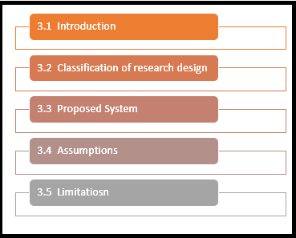

Figure 3‑1 List of Sub Sections in Research Methodology

## Classification of research

Research designs are broadly divided into two categories exploratory research and conclusive research. Exploratory research is broadly defined as the research design with a primary objective of providing insight into the research problem and confronting the researcher. This type of research design is incorporated into the system when the researcher is sure about the research problem, its course of actions and many other details about the research work. On the other hand conclusive research design is particularly used with an intention to assist the decision maker i.e.., the user of the research work by comparing, assessing and choosing the best fit course of action to be under taken in a particular situation. This approach in implement when quantitative research is involved.

The conclusive research design is again sub categorised in to two sub categories namely descriptive research design and casual research design. Descriptive type of research design the major aim is broadly describing something pertaining to the research area. This type of research design in incorporated when the researcher is required to provide predictions and perceptions about a specific topic. Whereas casual research is a conclusive type of research where the major target is to identify the cause and effect relationship in the research area.

In this research work we implement the conclusive research design i.e.., the sub category of conclusive descriptive research design referred as single cross sectional research design model because of the practical implementation of the software model of AIS with single sample from a single respondent. Descriptive design because it provides characteristics and implements functions associated to AIS by marking formulating and few specific hypothesis. Since this is a quantitative research approach where the focus is on the solution or results and it mainly involves usage of computational and technological techniques to draw a conclusion towards the research problem and provide a definite solution to the research seeker.

## Proposed System

In this section we describe the AIS from our perspective i.e.., how we perceived AIS. In this research proposed AIS consists of 6 stages. Proposed system may vary with systems proposed by other researchers and the existing framework and platform though the streamline activities may or may not differ with few extended stages and capabilities. The various stages implemented in our proposed systems include collecting data, balance sheet template, and automated income statement preparation, automated cash flow statement, analysis of financial statements using BI tools and finally generating dashboards, reports and graphs.

Stage-1 of this AIS systems includes collecting financial data, this stage involves manual intervention by any financial professional with accounting knowledge is required to collect all the financial transaction tractions incurred in that particular financial cycle. This stage also can be automated by few extra technological components such as bar code scanner or the picture snapshot reader, however this stage cannot be purely automated, because automation requires most of the transactions be recorded in almost same format, all the transactions may or may not be recorded in the billable format sometimes manual recording also is required, therefore stage 1 of collecting financial transactions may not be totally automated, as of now in this proposed system this stage requires manual intervention.

Stage-2 of this proposed system refers to balance sheet template, this can be briefly described as the combination of manual intervention and automated process. This stage of the system is incorporated on the Microsoft excel sheet platform with automation rules on validation of cells and clearing of data with excel coding and visual basic coding standards. Manual intervention is required to enter the data in the appropriate cells erroneous data is reflected with appropriate error messages, there by validation of data is under taken by the rules and validation rules in the excel sheet template. This stage manual intervention may not be performed by the financial professional or accountant any organization resource with minimum education qualification pertaining to the organizations standard can also be allotted activities involved in this stage.

Stage-3 of this proposed system involves automated generation of income statement, this stage does not require manual intervention except for the instance of launching the program. This stage takes input from the previous stage of the proposed system. From the balance sheet templated for the current month balance sheet is picked up from the specified location and extracts various fields and generates the income statement in the output folder location in report format can, which can be read and accessed in any basic editors ranging from notepad to Microsoft word to notepad++. This automation is developed using python 2.7 version platform.

Stage-4 of this proposed system involves automated generation of cash flow statement, this stage does not require manual intervention except for the instance of launching the program. This stage takes input from the previous two stages of the proposed system. From the balance sheet templated for the current month balance sheet is picked up from the specified location and extracts various fields as well as the income statement from the previous stage and extract the income statement field and many other information fields required for calculation of cash flow statement and the cash flow statement is generated in the output folder location in report format, which can be read and accessed in any basic editors ranging from notepad to Microsoft word to notepad++. This automation is developed using python 2.7 version platform.

Stage-5 of this proposed system involves automated generation of retained earnings statement, this stage does not require manual intervention except for the instance of launching the program. This stage takes input from the previous three stages of the proposed system. From the balance sheet templated for the current month balance sheet is picked up from the specified location and extracts various fields as well as the income statement from the previous stage and extract the income statement field and many other information fields and cash flow statement to extract many fields that are required for calculation of cash flow statement and the cash flow statement is generated in the output folder location in report format, which can be read and accessed in any basic editors ranging from notepad to Microsoft word to notepad++. This automation is developed using python 2.7 version platform.

Finally, stage-6 which is an elaborate stage where the input from the stage-1 is considered and is processed sing a business intelligence tool, in this project we are using tableau 9.0 version where the financial transactions are analysed and various outputs in the form of weekly, monthly and yearly report based upon the desired frequency reports are generated, dashboards and graphs plotted for the previous financial cycle transactions are provided as easy, quick, efficient, reliable and complete output to the management of the organization.

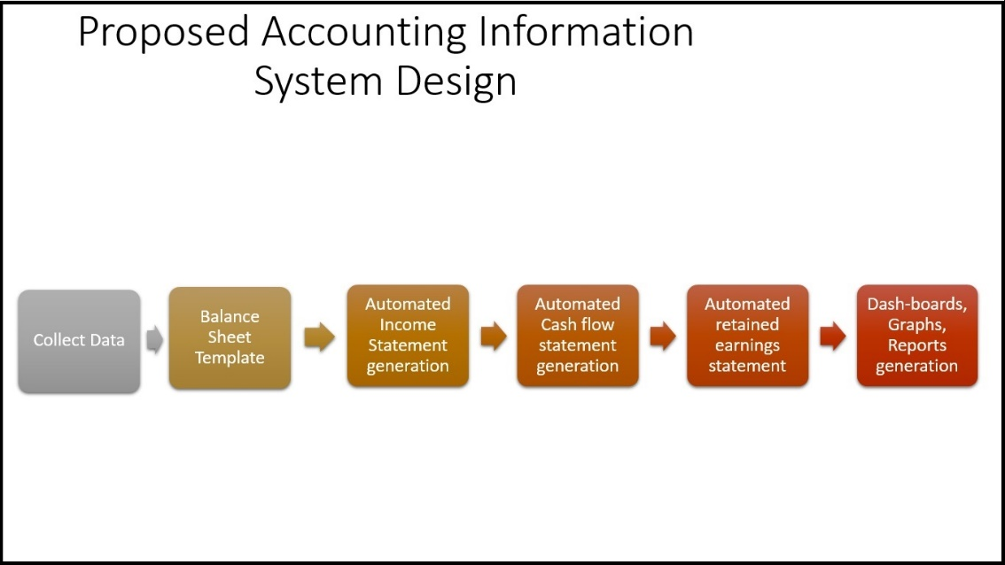

Figure 3‑2 Proposed AIS system design model

## Assumptions

This section provides a list of assumptions considered while designing the proposed AIS. First and foremost assumption of this model is in the stage-1 must be maintained in the form of journal in proper debit and credits format in correct and complete data with consistency. Next assumptions involves the balance sheet template provides basic rules for validation and verification of the input data entered but the user should have the due diligence to enter the data in balanced format, balancing of data is the users responsibility rather that the systems responsibility.

Finally in the stage-4 of the proposed system which involves automated generation of cash flow statement which takes balance sheet of the current financial cycle and the balance sheet of the previous balance sheet, if either of the sheet is not provided then the automation process stops until the respective input file is provided.

## Limitations

This section jot’s down few of the limitations of the proposed model of the AIS. Firstly limited number of samples more precisely since this proposed system follows single cross sectional descriptive research design the testing of the proposed model was carried out with single or maximum two to three financial data. Posting of journals is not in the scope of the proposed system. Balance sheet should be entered in balanced format by the users of the balance sheet template.

# **System Design Flow Chart**

The below figure (Figure 4-1) shows a brief flow chart of the proposed AIS system. As discussed in the previous section in this projects proposed system AIS system consists of 6 stages, out of which Stage-2 is developed in Excel using excel language for formulating validation rules and visual basic logic and Stage 3, 4 and 5 are merged together since all there are based on same platform i.e.., python 2.7 and are in pipelined sequence framework (Figure 4-2) shows a detailed flow chart of stage3, 4 and 5 combined program. Finally stage 6 is developed and based on BI tool namely tableau 9.0.

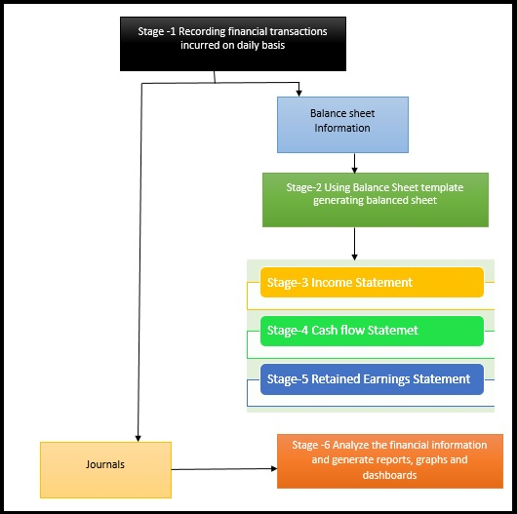

Figure 4‑1 Flow Chart of AIS

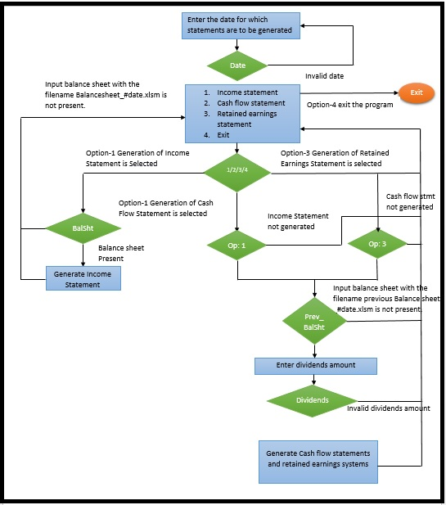

Figure 4‑2 Flow chart of the automation of financial statements sub system

# **AIS Software Design**

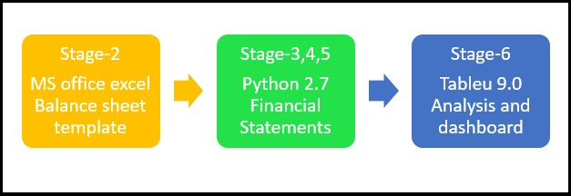

Figure 5‑1 Software flow between activities

As mentioned in the previous sections proposed AIS is composed of 6 stages but as per software coding point of view the software system is composed of 3 different technologies Stage-2 MS office excel, Stage-3, 4 and 5 python code and finally stage-6 is implemented on BI tool referred as tableau. Figure 5-1 shows the flow of software tools between different activities of the AIS model.

## Balance Sheet Template

Balance Sheet template works on the accounting principal

*Asset=Liabilities + Owners Equity + Revenue – Expenses*

Few of the features of the balance sheet template designed specifically for this proposed system are, firstly, all the description cells are dropdown cells which work dynamically in this way, drop down values are picked up from sheet 2 as and then drop down values change users can add or remove values from the specific column in the sheet 2, secondly, amount fields and conditional field population validation rules are added to the template, thirdly, summation and deduction formulas are covered in the balance sheet template, finally, a clear button which works on visual basics language which clears all the data fields for new data population. Figure 5.2 shows the sample screen shot the balance sheet template. Figure 5.3 shows the drop down list population.

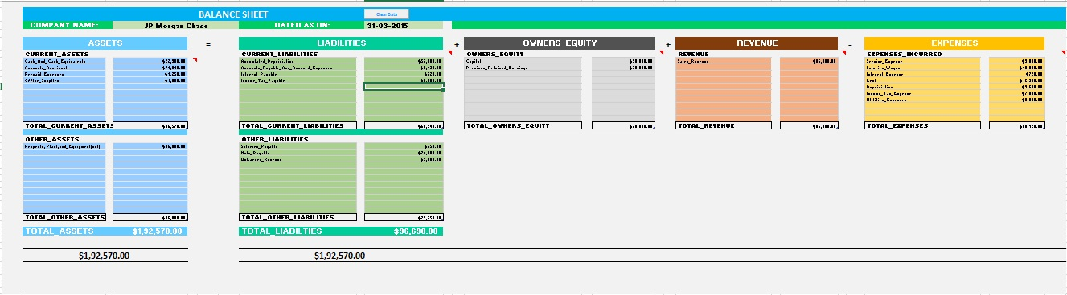

Figure 5‑2 Balance Sheet Template Screen Shot

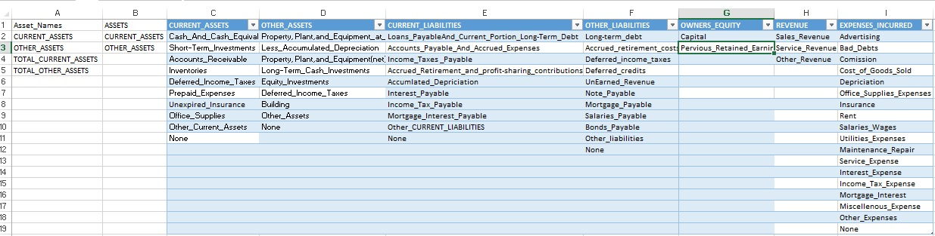

Figure 5‑3 Drop-Down Population Data

## Generation of Financial Statements Automation through PYTHON

Briefly describing the financial statement, Balance Sheet shows the overview of assets, liabilities, revenue earned, owners’ equity and expenses incurred except for the dividends paid(if any). Indirect Income Statement refers to statement that describes the financial status by displaying different types of revenues earned, expenses incurred and finally gain or loss achieved. Cash flow statements showcase the summary of the cash in-flow and cash out-flow faced in the financial cycle. Retained earnings statement defined the amount retained after paying dividend’s to the stakeholders at the end of the financial cycle.

For this specific stage of the proposed system python is referred to as the preferred platform and software language because of its easily available free ware software, easily readability and comparatively easily understandable coding framework, and efficient and easy source maintenance and finally many libraries imported to the IDE and no supporting software required to execute the python source code etc. Output of the Generate Statements python code generates income statement, cash flow statement and retained earnings statement in text format. Below code snipped is the source code snipped of the GenerateStstement.py python source file.

__author__ = **'Arshiya28'  
  
from** openpyxl **import** load_workbook  
**import** os,sys  
  
**def** createIncomeStatement(inputFile):  
 wbFile = load_workbook(filename = inputFile, use_iterators = True)  
 sheet_ranges = wbFile[**'Sheet1'**]  
 date = sheet_ranges[**'J3'**].value  
 suffix = date.replace(**"-"**,**""**)  
 outputFile = open(**'C:\Users\Arshiya28\Desktop\MBA\Project\Software\Step-2\Output\IncomeStatement_'**+suffix,**"wb"**)  
 outputFile.write(**"================================================================================================\n"**)  
 outputFile.write(**" INCOME STATEMENT\n"**)  
 outputFile.write(**"================================================================================================\n"**)  
 outputFile.write(**"Company Name: "**+sheet_ranges[**'D3'**].value+**"\n"**)  
 outputFile.write(**"For the Year Ending "**+date+**"\n"**)  
 outputFile.write(**"================================================================================================\n"**)

*# Logic for preparing the income statement*

*# Taking input as the balance sheet obtained from stage 2*

*# Excel sheet formal this function reads the data from balance sheet in excel sheet format*

*# generates output in text format as IncomeStatement_<Data entered by the user>*

outputFile.write(**"-------------------------------------------------------------------------------------------------\n"**)  
netIncomeAfterTax = netIncomeAfterInterest - income_tax_expense  
outputFile.write(**" NET INCOME After TAX $"**+**"%.2f"** % netIncomeAfterTax + **"\n"**)  
outputFile.write(**"=================================================================================================\n"**)

**if** netIncomeAfterTax < 0:  
 outputFile.write(**" NET LOSS $"**+**"%.2f"** % netIncomeAfterTax + **"\n"**)  
**elif** netIncomeAfterTax > 0:  
 outputFile.write(**" NET PROFIT $"**+**"%.2f"** % netIncomeAfterTax + **"\n"**)  
**elif** netIncomeAfterTax == 0:  
 outputFile.write(**" BREAK EVEN POINT $0.00\n"**)  
outputFile.write(**"=================================================================================================\n"**)  
outputFile.close()  
**return** netIncomeAfterTax

**def** createCashFlowStatements(inFile1,infile2,netIncome):  
  
 addition = {}  
 substraction = {}  
 *# First Balance Sheet* wbFile1 = load_workbook(filename = inFile1, use_iterators = True)  
 sheet_ranges1 = wbFile1[**'Sheet1'**]  
 *#Second Balance Sheet* wbFile2 = load_workbook(filename = infile2, use_iterators = True)  
 sheet_ranges2 = wbFile2[**'Sheet1'**]  
  
 *#Header Population* date = sheet_ranges1[**'J3'**].value  
 suffix = date.replace(**"-"**,**""**)

*# Logic for preparing the cash flow statement*

*# Taking input as the balance sheet obtained from stage 2 and few values from the previous sub routine of income statement to generate cash flow statement in text format CashflowStatement_<date entered by user>*

totalCash = totalCash + totalofOperations + totalofInvesting + totalofFinancing  
 line = **"CASH AT THE END OF FINACIAL YEAR"  
if** len(line) < 61:  
 trailing_spaces = 61-len(line)  
 line = line + **" "** * trailing_spaces  
 line = line + **"$"**+**"%.2f"** % float(totalCash)  
 outputFile.write(line+**"\n"**)  
outputFile.write(**"================================================================================================\n"**)  
outputFile.close()

**def** createRetainedEarningStatement(inFile1,netIncome,dividends):  
 *# First Balance Sheet* wbFile1 = load_workbook(filename = inFile1, use_iterators = True)  
 sheet_ranges1 = wbFile1[**'Sheet1'**]  
 ws1 = wbFile1.get_sheet_by_name(name = **'Sheet1'**)  
 *# Previous Retained Earning* p = 7  
 q = **""**

*# Logic for preparing the cash flow statement*

*# Taking input as the balance sheet obtained from stage 2 and few values from the previous sub routine of income statement and cash flow statement to generate cash flow statement in text format RetainedEarningsStatement_<date entered by use>*

outputFile.write(**" Previous Retained Earnings $"**+**"%.2f"** % retear + **"\n"**)  
outputFile.write(**" Net Income from Income Statement $"**+**"%.2f"** % netIncome + **"\n"**)  
outputFile.write(**" Dividends paid to Shareholders $"**+**"%.2f"** % dividends + **"\n"**)

outputFile.write(**"------------------------------------------------------------------------------------------------\n"**)  
totals = (retear + netIncome) - dividends  
outputFile.write(**" RETAINED EARNING at "**+date+**" $"**+**"%.2f"** % totals +**"\n"**)  
outputFile.write(**"------------------------------------------------------------------------------------------------\n"**)  
outputFile.close()

*# Main Program***if** __name__ == **"__main__"**:  
 **print "Program to Generate Financial Statements."  
 print "------------------------------------------------------------------------------------------------------"** inputDate = raw_input(**"Enter the date for which financial statements to be generated(ddmmyyyy): \t"**)  
 **print** inputDate  
 balanceSheet = **'C:\Users\Arshiya28\Desktop\MBA\Project\Software\Step-2\Input\Balance_Sheet_'**+inputDate+**'.xlsm'  
 print** balanceSheet  
 flag = 0  
 netIncome = 0  
 **if not** os.path.isfile(balanceSheet) :  
 **print "\nInput Balance Sheet for the date "**+inputDate+**" does not exists!!!!"  
 print "Exiting the program."** sys.exit(99)  
  
 **while** True:  
 **print "============================================================="  
 print "Financial Statements:"  
 print "============================================================="  
 print "1. Income Statement"  
 print "2. Cash Flow Statement"  
 print "3. Retained Earning Statement"  
 print "4. Exit"** option=raw_input(**"Enter the Option: \t"**)  
 **print** type(option)  
 **if** option **not in** [**"1"**,**"2"**, **"3"**, **"4"**]:  
 **print "Invalid Input!!!!"  
 print "Enter an option 1 to 4"  
 elif** option == **"1"**:  
 **print "Generating Income Statement!!!!!"** flag = 1  
 netIncome = createIncomeStatement(balanceSheet)  
 **# Generate Income Statement**  
 **elif** option == **"2"**:  
 **if not** os.path.isfile(**'C:\Users\Arshiya28\Desktop\MBA\Project\Software\Step-2\Output\IncomeStatement_'**+inputDate):  
 **print "For generating cash flow statement. Income statement should be generated."  
 print "Please Select option 1 before selecting option 2."**   
 **print "Generating Cash Flow Statement!!!!!"** createCashFlowStatements(balanceSheet,file2,float(netIncome))  
 **# Generate Cash Flow Statement**  
 **elif** option == **"3"**:  
 **if not** os.path.isfile(**'C:\Users\Arshiya28\Desktop\MBA\Project\Software\Step-2\Output\IncomeStatement_'**+inputDate):  
 **print "For generating cash flow statement. Income statement should be generated."  
 print "Please Select option 1 before selecting option 3."**  
 **print "Generating Retained Earning Statement!!!!!"** createRetainedEarningStatement(balanceSheet,float(netIncome),float(dividends))  
 **# Generate Retained Earnings Statement  
 elif** option == **"4"**:  
 **print "Option 4 Selected !!!!!!!!!!!"  
 print "Existing the Program."** sys.exit(0)

### Output Generated out of the GenerateStatements.py

#### Income Statement

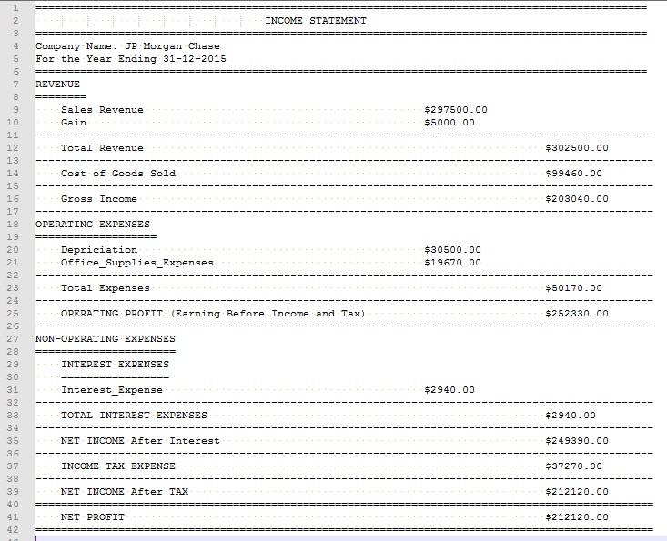

Figure 5‑4 Income Statement Screen-Shot

#### Cash Flow Statement

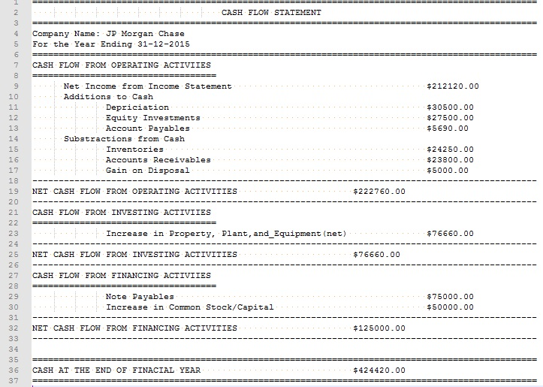

Figure 5‑5 Cash-Flow Statement Screen-Shot

#### Retained Earnings Statement

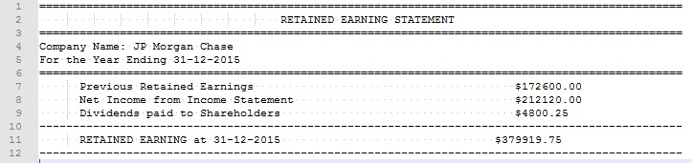

Figure 5‑6 Retained Earnings Statement Screen-Shot

### Analysis and generation of repots ad dashboards using TBALEAU

AIS not only generates the financial statements also does the las bit of processing the financial information analysing it and generating reports and dash board for easy, efficient and optimal decision making process. In this project tableau 9.0 version was opted because of its advanced technology in the business intelligence stream. It provides an elaborate environment to analysis in all possible length and breadths in all 360 degree angles with respect to multi variables across multiple tangents. It also provided flexibility in import data from different input file formats for as convenient text format to as complex as exporting from other databases tables such as oracle, MY SQL etc. In our system excel sheet us imported and analysed and weekly reports and dashboard is generated as a sample. Figure 5-7 shows the sample screen shot of the analysed data through tableau.

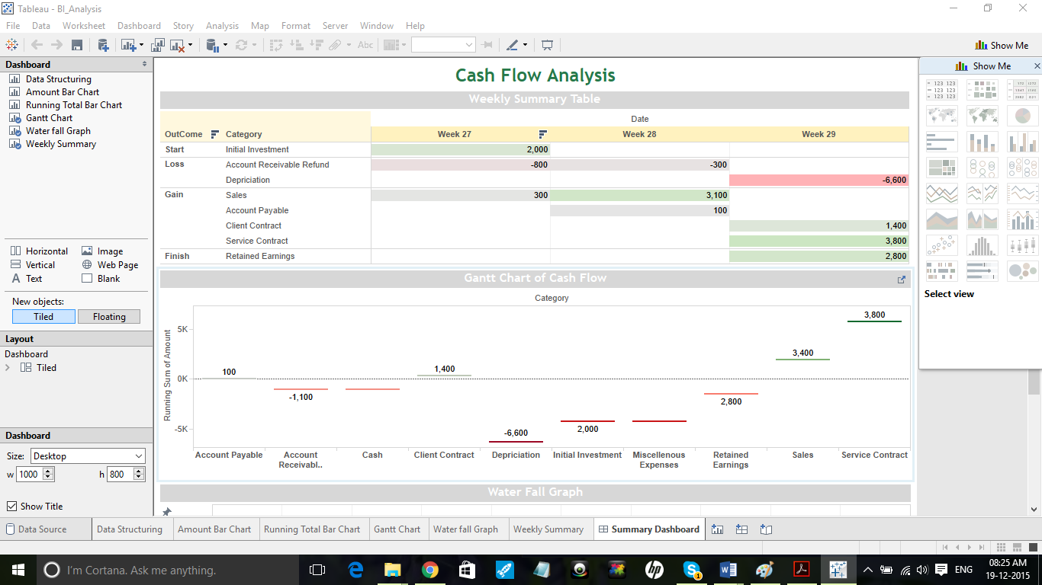

Figure 5‑7 Dashboard generated through tableau 9.0

## Scope for Future Research

Though the proposed AIS is extensively worked upon there are many more future enhancement opportunities. Few identified research opportunities are:

* The manual intervention of collecting financial information with respect to the transactions occurred in the organization may not be totally removed but can be minimized to a greater extent.
* In this system balance sheet validation with few advanced features are handled but generation of balance sheet can also be automated if the collection is automated in a proper desirable format.
* Automation of not only generating financial statements but also enhancing it to provide possible financial ratios
* Tableau features can be further explored to get even more analysed and processed information so that management task can be further minimised.

# **Conclusion**

The Study is intended to identify the capability of information technology in the accounting field. The project focuses on establishment of a reliable connection between the information technology and the organization accounting department to enhance the organizations performance through automation and business intelligence analysis of the financial statements to enable and offer extended capability with respect to the decision making process ultimately leading to organization profitability and reduction of opportunity cost over other equally competitive organizations in the market.

In the current proposed a composition of three different technologies is applied to obtain desired result thereby providing the vital implication that information technology and accounting system are compatible enough to automate the accounting processes and reduce manual intervention in the accounting process and supporting automation process to progress and implemented in many more business processes. The number of technologies used and incorporated can be reduced or increased based upon the convenience of the management and the resources, but moderate number of technologies used may have less overhead of resource training, maintenance and licensing issues ultimately lead to cost overhead.

With the shift in the management style and many other aspects of the business automating the accounting process will have a high impact on various operations and activities carried out in the organization, if incorrect type of accounting information system with inappropriate sages in indifferent context may have a reverse and irreversible undesirable results.

Finally concluding appropriate best fit between accounting information system and organization other associated business processes may help the organization achieve profitability and high performance in many different aspects of the business but the same can have reverse adverse effect if not achieved proper fit.

# **References**

Alsharayri, M. A., 2011. The E-commerce Impact on Improving Accounting Information Systems in Jordanian Hotels. *International Research Journal of Finance and Economics.*

Anon., 2001-2015. *Python Software Foundation.* [Online]   
Available at: https://www.python.org/about/

Anon., 2014. *Excel Macros (VBA) For beginners, intermediate and advanced users.* [Online]   
Available at: http://www.excel-vba.com/excel-vba-solutions-beginners.htm  
[Accessed 2015].

Boulianne, E., 2007. Revisiting fit between AIS design and performance with the analyser strategic-type. *International Journal of Accounting Information Systems.*

Bovee, M., 2004. Empirical Validation of the Structure of an Information Quality Model. *International Conference on Information Quality.*

Chang, Y. W., 2001. Contingency factors and accounting information system design in Jordanian companies. *Journal of Accounting Information System.*

Chenhall, R., 2003. Management control systems design within its organizational. *Accounting, Organizations and Society.*

Doms, M. E. J. R. S. &. K. S. D., 2004. Information technology investment and firm performance in U.S. retail trade. *Economics of Innovation and New Technology.*

Downes, A. & Barclay, N., 2008. The Role of Performance Management in Organizations.

Elena Urquía Grande, R. P. E. C. M. C., 2010. The impact of Accounting Information Systems on performance measures.

Eugene F. Brigham, J. F. H., 2012. *Fundamentals of Financial Management.* 12 ed. s.l.:s.n.

Flores, Y. S. &., 2001. Information Quality: Meeting the Needs of the Consumer. *International Journal of Information Management.*

FOLORUNSHO, M., 2006. IMPACT OF AUTOMATED ACCOUNTING SYSTEM ON PAYROLL PREPARATION IN SOME SELECTED LARGE ORGANISATIONS.

Foundation, T., 2015. *Tableau Training & Tutorials.* [Online]   
Available at: http://www.tableau.com/learn/training

Gerdin J., G. J., 2004. Forms of contingency fit in management accounting research – a critical review. *Accounting, Organization and Society.*

Guido van Rossum, a. F. L. D. J., 2006. *The Python Language Reference Manual.* s.l.:Network Theory Ltd.

Guttag, J. V., 2013. *Introduction to Computation and Programming Using Python.* Spring 2013 Edition ed. s.l.:s.n.

H. Sajady, M. D. &. H., 2008. Evaluation of the effectiveness of accounting information systems. *International Journal of Information Science & Technology,* Volume 6.2.

Hunton, J., 2002. Blending information and communication technology with accounting research. *Accounting Horizons.*

Izedonmi .P.F, 2005. Manual on Research report writing.

J. Bouwens, M. A. A., 2000. The consequences of customization on management accounting systems design. *Accounting, Organizations and Society.*

L. A. Gordon, D. M., 1976. A contingency framework for the design of accounting information systems. *Accounting, Organizations and Society.*

Mark Lutz, O. M., 2009. *Python Pocket Reference.* 4 ed. s.l.:s.n.

McDonald, D. H. a. K., 2001. *The Quick Python Book.* s.l.:Manning.

Mitchell, F. R. G. a. S. J., 2000. A Case for Researching Management Accounting in SME’s. *Management Accounting: Magazine for Chartered Management Accountants.*

Mohammed Al-Omiri a, C. D., 2007. *A survey of factors influencing the choice of product costing systems in UK organizations,* UK: s.n.

Naresh K. Malhotra, S. D., 2012. *Marketing Research - An Applied Orientation.* 6 ed. s.l.:s.n.

Navdal, R., 2008. Value Relevance of Accounting Information: Emphasis on the Financial Crisis.

Nicolaou, A., 2000. A Contingency Model of Perceived Effectiveness in Accounting. Information Systems: Organizational Coordination and Control Effects.

Oguntimehin, A., 2001. Some practical strategies for successful implementation of universal basic education in Nigeria. *African Journal of Educational Management.*

Patel, B. P., 2015. Effects of accounting information system on Organizational Profitability.

P, M. S., 2008. Effects of Internal Control Systems on Financial Performance in an Institution of Higher Learning in Uganda.

Reference, P. E., 1999. *David M. Beazley.* s.l.:New Riders.

Rono, E., 2006. Effectiveness of the internal control system in management of finances in public universities in Kenya.

Sajady H, D. M. H., 2008. Evaluation of the effectiveness of accounting information systems. *International Journal of Information Science & Technology.*

Salehi Mahdi, V. R. a. A. M., 2010. Usefulness of Accounting Information System in Emerging Economy.

Steinbart., M. B. R. &. P. J., 2012. *Accounting Information System.* 12 ed. s.l.:s.n.

Tam, T. C.-W., 2011. The relevant information technology knowledge and skills for accounting graduates in New Zealand. *Southern Cross University.*

Tidd J., B. J. &. P. K., 2005. Managing Innovation Integrating Technological, Market and Organizational Change.

U. Hoitash, R. H. a. J. C. B., 2009. Corporate governance and internal control over financial repaorting; a comparison of regulatory regimes.

Wilkinson, J. W. C. M. J. R. V. &. W.-O.-W., 2000. Accounting information systems: Essential concepts and applications.

Yang H. M., L. S. W. a. K. L. T., 2011. The impact of computerized internal control adaptation on operating performance.

Zare, I. N. J. P. A. S. F. M. S., 2013. Role of accounting information systems on relevance of accounting information. *Life Science Journal.*

Zhang, I. X., 2002. Economic consequences of the Sarbanes Oxley Act.. *Account. Economics..*